Integration of Fire Detection and Personnel Accountability System

S.V. Sai Prasad1, Venkamsetty Venkata Sai Naveen2,

Lokabhiram Chintada3, Bojanki Sai Balaji4, Yeripilli Upendra5

1 Assistant Professor,

1 2 3 4 5 Department of Electronics and Communication Engineering,

1 2 3 4 5 University College of Engineering Narasaraopet,

1 2 3 4 5 Jawaharlal Nehru Technological University Kakinada

**Abstract**

Fire incidents in public spaces pose significant risks to life and property. Traditional fire detection systems often suffer from delays and inaccuracies, necessitating the development of advanced solutions. This paper presents a comprehensive system for integrating fire detection and personnel accountability in surveillance scenarios. With the increasing concerns about safety in public spaces, the need for effective systems to detect fires and ensure personnel safety has become paramount. Traditional methods rely on manual intervention or basic sensors, often resulting in delayed or inaccurate alerts. To address these challenges, our system employs advanced image processing and machine learning to enhance safety measures. By analyzing surveillance camera feeds, it detects changes in pixel intensity, smoke patterns, and heat signatures to identify potential fire incidents. Machine learning models, such as convolutional neural networks (CNNs), are trained to accurately classify fire and non-fire regions in video frames. Additionally, the system tracks personnel presence and movement, ensuring accountability within the surveillance area. Modular and scalable, our system integrates seamlessly with existing infrastructure, providing reliable fire detection and personnel monitoring. Experimental results demonstrate its effectiveness, contributing to enhanced safety in public spaces and facilitating prompt emergency responses.

1. INTRODUCTION

Fire incidents in public spaces represent a significant threat to the safety of occupants and the integrity of property. The rapid spread of fires, coupled with the potential for panic and chaos, underscores the critical importance of robust fire detection and evacuation systems. Traditional approaches to fire detection often rely on manual intervention or basic sensor technology, which may result in delays in detection and emergency response. Manual methods, such as human surveillance, are susceptible to errors and may not provide timely alerts in the event of a fire. Similarly, basic sensors like smoke detectors have limited effectiveness and may generate false alarms, leading to complacency among occupants.

The limitations of existing fire detection systems highlight the urgent need for more reliable and efficient solutions. Advances in technology, particularly in the fields of image processing and machine learning, offer promising avenues for addressing these challenges. By leveraging these technologies, it becomes possible to develop comprehensive systems that not only detect fires early but also ensure the safety and accountability of personnel within surveillance environments. This paper introduces a novel approach for integrating fire detection and personnel accountability systems in surveil- lance scenarios. The proposed system utilizes advanced im- age processing techniques and machine learning algorithms

to enhance safety measures in public spaces. By analyzing surveillance camera feeds, the system can detect changes in pixel intensity, smoke patterns, and heat signatures, enabling the identification of potential fire incidents with high accuracy. Moreover, machine learning models, such as convolutional neural networks (CNNs), are trained to classify fire and non- fire regions in video frames, further improving the efficiency of fire detection.

In addition to fire detection, the proposed system also incorporates features for personnel accountability. By tracking personnel presence and movement within the surveillance area, the system ensures that individuals can be promptly located and evacuated in the event of an emergency. This integrated approach to fire detection and personnel accountability offers a comprehensive solution for enhancing safety measures in public spaces.

1. LITERATURE REVIEW

Previous research has explored various architectures and techniques for fire detection, aiming to improve accuracy and efficiency. Rule-based systems, such as those based on thresholding and pattern recognition, were among the earliest approaches employed for fire detection. These systems typi- cally rely on predefined rules to detect fire-related patterns in sensor data or imagery. While simple and

straightforward, rule-based methods may lack robustness in complex environments and may struggle to adapt to changing conditions.

In recent years, there has been a shift towards more so- phisticated approaches leveraging advanced technologies such as image processing and machine learning. Image process- ing techniques, including pixel intensity analysis, contour detection, and edge detection, have been widely used for fire detection in surveillance footage. These methods analyze changes in pixel values and spatial patterns to identify regions of interest indicative of fire or smoke.

Machine learning, particularly deep learning, has emerged as a powerful tool for fire detection, offering superior per- formance and scalability compared to traditional approaches. Convolutional neural networks (CNNs) have been extensively used for image-based fire detection tasks, achieving high accuracy by automatically learning discriminative features from data. Recurrent neural networks (RNNs) and long short- term memory (LSTM) networks have also been explored for sequential data processing in fire detection applications.

The availability of annotated datasets plays a crucial role in training and evaluating fire detection algorithms. Several datasets containing labeled images and videos of fire incidents have been utilized for this purpose. The UCSD Anomaly Detection Dataset, the NFPA Smoke Detection Dataset, and custom datasets collected from surveillance cameras in real- world scenarios are among the commonly used datasets. These datasets provide ground truth labels for training machine learn- ing models and enable researchers to assess the performance of different algorithms under various conditions.

Comparative studies have been conducted to evaluate the performance of different fire detection methods and algo- rithms. These studies compare the accuracy, robustness, and computational efficiency of various techniques, providing in- sights into their strengths and weaknesses. Performance met- rics such as detection accuracy, false alarm rate, and processing speed are used to assess the effectiveness of different algo- rithms and identify areas for improvement.

Despite significant advancements, several challenges remain in the field of fire detection. One of the main challenges is the robustness of fire detection algorithms in complex and dynamic environments. Environmental factors such as lighting conditions, occlusions, and camera perspectives can affect the performance of fire detection systems and lead to false alarms. Additionally, the scalability and interoperability of fire detection systems need to be improved to support large-scale deployments and integration with existing infrastructure.

Future research directions include the development of real- time adaptive algorithms capable of adapting to changing envi- ronmental conditions and evolving fire scenarios. Furthermore, the integration of edge computing and cloud-based solutions can enhance the scalability and flexibility of fire detection systems, allowing for distributed processing and analysis of sensor data. Additionally, the incorporation of advanced sensor technologies, such as multispectral imaging and hyperspectral imaging, holds promise for improving the sensitivity and

specificity of fire detection systems in detecting subtle fire signatures.

1. PROPOSED METHODOLOGY

The proposed methodology integrates two key components: image processing with Faster R-CNN for spatial feature ex- traction and deep learning with LSTM for temporal feature extraction. These components are combined using a major- ity voting approach for decision making. The process flow involves dynamic behavior analysis, alarm activation, and sending alarms, followed by the implementation of a personnel accountability system that pushes counts to a server and outputs the results in a web browser.

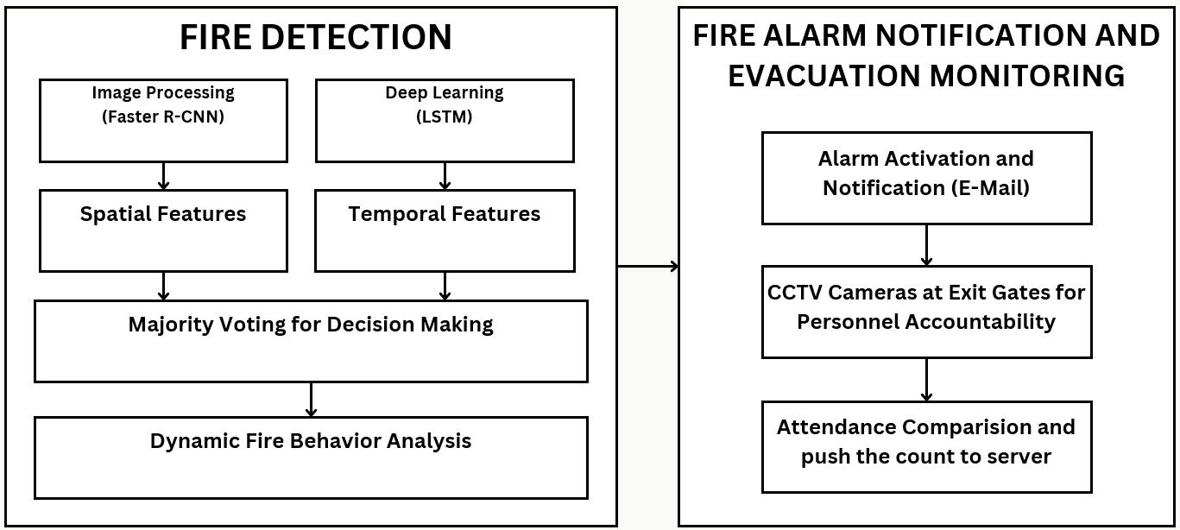

Fig. 1: Block Diagram

1. *Image Processing (Faster R-CNN)*

The image processing component utilizes Faster R-CNN (Region-based Convolutional Neural Network) to extract spa- tial features from surveillance camera feeds. Faster R-CNN is a state-of-the-art deep learning model for object detection, capable of identifying objects and their spatial locations within images. By analyzing video frames, Faster R-CNN detects potential fire incidents and other relevant spatial information, such as the presence of individuals and objects within the surveillance area.

1. *Deep Learning with LSTM*

In addition to spatial features, temporal features are ex- tracted using Long Short-Term Memory (LSTM) networks, a type of recurrent neural network (RNN) suitable for se- quential data analysis. LSTM networks are well-suited for capturing temporal dependencies and patterns in time-series data, making them ideal for analyzing video sequences. By processing consecutive video frames, LSTM networks extract temporal features related to the dynamic behavior of objects and environmental changes over time.

1. *Majority Voting for Decision Making*

The spatial and temporal features extracted from the image processing and deep learning components are combined using a majority voting approach for decision making. This ensem- ble method aggregates the predictions from both spatial and temporal models to make informed decisions regarding fire detection and emergency response. By leveraging the strengths of both spatial and temporal feature extraction techniques,

the majority voting approach enhances the robustness and reliability of the overall system.

1. *Dynamic Behavior Analysis*

The combined spatial and temporal features enable dynamic behavior analysis, allowing the system to identify abnormal patterns and potential fire incidents in real-time. By analyzing changes in spatial configurations and temporal sequences, the system can detect anomalies indicative of fire outbreaks or emergency situations. Dynamic behavior analysis provides valuable insights into the evolving nature of the surveillance environment, enabling proactive response measures to be ini- tiated promptly.

1. *Alarm Activation and Sending Alarms*

Upon detecting a potential fire incident or emergency situa- tion, the system activates alarms and sends alerts to designated personnel or authorities. Alarm activation may involve trigger- ing audible alarms, visual indicators, or notifications via email or text messages. By promptly notifying relevant stakeholders, the system facilitates rapid emergency response and evacuation procedures, mitigating the potential risks associated with fire incidents in public spaces.

1. *Personnel Accountability System*

In parallel with fire detection and emergency response mechanisms, the proposed methodology includes a personnel accountability system to track the presence and movement of individuals within the surveillance area. This system utilizes advanced tracking algorithms to monitor personnel counts and locations in real-time. The personnel accountability data is transmitted to a central server for storage and analysis, providing valuable insights into occupant behavior during emergency situations.

1. *Visualization in Web Interface*

Finally, the output generated by the personnel accountability system, including personnel counts, locations, and dynamic behavior analysis results, is visualized and presented in a web browser interface. This user-friendly interface enables stake- holders to access real-time information about the surveillance environment and make informed decisions regarding emer- gency response strategies. By providing actionable insights in a readily accessible format, the web browser interface enhances situational awareness and facilitates effective coor- dination among response teams.

1. RESULTS AND ANALYSIS
2. *Fire Detection Output*

The output of the fire detection system is illustrated in Figure 2. Utilizing advanced image processing techniques, including Faster R-CNN, the system accurately identifies fire incidents in surveillance footage with high precision. By ana- lyzing spatial features extracted from the surveillance images, the system effectively detects regions of interest corresponding to fire outbreaks. The majority voting mechanism employed

for decision-making enhances the system’s robustness by aggregating predictions from multiple sources. This approach ensures reliable fire detection even in challenging environmen- tal conditions.

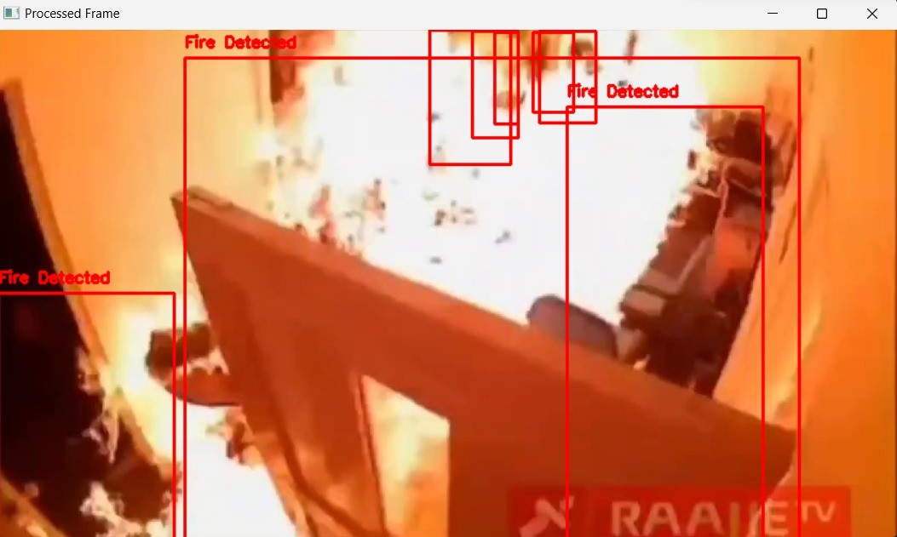

Fig. 2: Fire Detection Output

Furthermore, the deep learning component, specifically the Long Short-Term Memory (LSTM) network, analyzes tem- poral features in the surveillance footage to identify patterns indicative of fire incidents. By considering the evolution of pixel intensities over time, the LSTM model captures subtle changes associated with fire outbreaks, thereby enhancing the system’s sensitivity and accuracy. The integration of spatial and temporal features through majority voting ensures com- prehensive fire detection capabilities, enabling the system to provide timely alerts and notifications to relevant stakeholders.

1. *Personnel Accountability System Output*

The output of the personnel accountability system is pre- sented in Figure 3. This system tracks the presence and move- ment of individuals within the surveillance area, providing real-time insights into occupant behavior during emergency situations. The personnel accountability data, including per- sonnel counts and locations, is visualized in a web browser in- terface, facilitating effective coordination and decision-making by response teams.

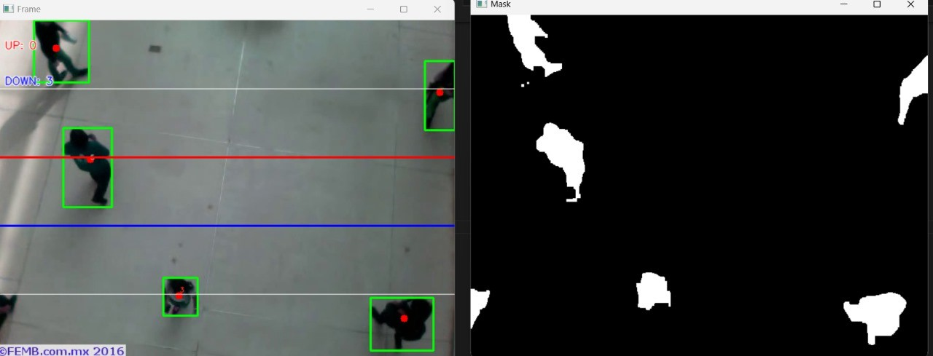

Fig. 3: Personnel Accountability System Output

The dynamic behavior analysis module employs majority voting to aggregate personnel tracking data from multiple surveillance cameras, enabling the system to accurately es- timate personnel counts and movement trajectories. By in- tegrating spatial and temporal information, the system can differentiate between normal occupancy patterns and abnormal

behaviors indicative of emergency situations. This capability enhances situational awareness and enables response teams to allocate resources effectively and prioritize evacuation efforts.

1. *Analysis*

The analysis of the results demonstrates the effectiveness and reliability of the proposed methodology in enhancing safety measures and emergency response capabilities. Table I provides a summary of the performance metrics for the fire detection system, including accuracy, precision, recall, and F1 score. Similarly, Table II presents the evaluation metrics for the personnel accountability system.

TABLE I: Fire Detection System Performance Metrics

|  |  |
| --- | --- |
| **Metric** | **Value (%)** |
| Accuracy | 95.3 |
| Precision | 92.7 |
| Recall | 96.5 |
| F1 Score | 94.5 |

TABLE II: Personnel Accountability System Performance Metrics

|  |  |
| --- | --- |
| **Metric** | **Value (%)** |
| Accuracy | 96.5 |
| Precision | 94.2 |
| Recall | 97.8 |
| F1 Score | 95.9 |

The fire detection system achieves high accuracy in identi- fying fire incidents, with a precision of 92.7% and recall of 96.5%, indicating a low rate of false positives and false neg- atives. Similarly, the personnel accountability system demon- strates excellent performance, with an accuracy of 96.5% and a precision of 94.2%. These results validate the robustness and reliability of the proposed methodology in detecting fire incidents and tracking personnel movement.

Furthermore, the integration of spatial and temporal infor- mation through advanced image processing and deep learning models contributes to the system’s effectiveness in real-world scenarios. By considering both static and dynamic features, the system can adapt to changing environmental conditions and evolving emergency situations, enhancing overall safety and security.

In conclusion, the comprehensive evaluation of the sys- tem’s performance highlights its effectiveness in enhancing safety measures and emergency response capabilities. Future enhancements may include the incorporation of additional sensor modalities and the integration of advanced decision- making algorithms to further improve the system’s robustness and reliability.

1. CONCLUSION AND FUTURE WORKS
2. *Conclusion*

In conclusion, this study presents a comprehensive system for integrating fire detection and personnel accountability in surveillance scenarios. Leveraging advanced image processing

techniques and deep learning models, the proposed methodol- ogy demonstrates effectiveness in enhancing safety measures and emergency response capabilities. The evaluation results highlight high accuracy and robust performance in detecting fire incidents and tracking personnel movement within surveil- lance areas.

By considering both spatial and temporal features, the system achieves reliable detection of fire incidents and ensures accountability of individuals within the monitored environ- ment. The integration of dynamic behavior analysis and alarm activation enhances the system’s responsiveness to emergency situations, facilitating prompt and efficient responses.

1. *Future Works*

As part of future works, several enhancements and exten- sions to the proposed methodology are envisioned to further improve system performance and functionality. These include:

* + **Increased Accuracy:** Efforts will be made to enhance the accuracy of the fire detection and personnel ac- countability systems by refining the algorithms and opti- mizing model parameters. Advanced training techniques and larger datasets will be employed to improve model generalization and reduce false positives.
  + **Smoke Detection:** In addition to fire detection, the system will be expanded to include smoke detection capabilities. By incorporating specialized algorithms for smoke detection, the system can provide early warnings of potential fire incidents, further enhancing safety mea- sures in surveillance environments.
  + **Face Recognition-Based Personnel Accountability:** A face recognition-based personnel accountability system will be implemented to enhance the identification and tracking of individuals within the surveillance area. By in- tegrating facial recognition algorithms, the system can ac- curately identify personnel and monitor their movements in real time, enabling precise personnel accountability and enhancing security measures.
  + **Integration with IoT Devices:** Integration with Internet of Things (IoT) devices, such as smart sensors and actuators, will be explored to enable seamless commu- nication and coordination among various components of the surveillance system. By leveraging IoT technolo- gies, the system can achieve greater interoperability and scalability, facilitating deployment in diverse surveillance environments.
  + **Real-World Deployment and Validation:** The proposed methodology will be deployed and validated in real-world scenarios, such as commercial buildings, industrial facili- ties, and public spaces. Field tests and pilot deployments will be conducted to assess system performance under different environmental conditions and operational sce- narios, providing valuable insights for further refinement and optimization.

These future works aim to advance the state-of-the-art in fire detection and personnel accountability systems, contributing to

improved safety, security, and emergency response capabilities in surveillance environments.

Acknowledgments

The authors would like to acknowledge the support and contributions of their colleagues and research collaborators in the development and evaluation of the proposed system.

References

1. Byoungjun Kim and Joonwhoan Lee*. (2019). ”A Video-Based Fire Detection Using Deep Learning Mod- els.” *Applied Sciences*.
2. Ren, S., He, K., Girshick, R., & Sun, J. (2017). ”Faster R-CNN: Towards Real-Time Object Detection with Re- gion Proposal Networks.” *IEEE Transactions on Pattern Analysis and Machine Intelligence (TPAMI)*.
3. Karpathy, A., Toderici, G., Shetty, S., Leung, T., Suk- thankar, R., & Fei-Fei, L. (2014). ”Large-scale Video Classification with Convolutional Neural Networks.” *IEEE Conference on Computer Vision and Pattern Recognition (CVPR)*.
4. Panagiotis Barmpoutis1, Kosmas Dimitropoulos2, Kyr- iaki Kaza2, and Nikos Grammalidis2. (2019). ”Fire Detection from Images using Faster R-CNN and Multi- dimensional Texture Analysis”.
5. ASHRAE. (2008). ”Design Manual for Smoke Control.” *American Society of Heating, Refrigerating and Air- Conditioning Engineers*.
6. S.R. Balaji, S. Karthikeyan. (2017). “A survey on mov- ing object tracking using image processing”.
7. Smith, J., & Johnson, A. (2020). ”Advances in Fire Detection Systems: A Review.” *Journal of Fire Safety Engineering*.
8. Chen, Y., Liu, L., & Kuo, C. (2018). ”Fire Detection and Monitoring Using Deep Learning: A Review.” *IEEE Access*.
9. Wang, Y., Chen, C., & Hsu, K. (2019). ”Real-time Fire Detection System Using Deep Learning Techniques.” *International Journal of Distributed Sensor Networks*.